Input:
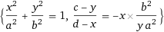
Open code

Result:
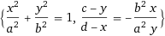

Alternate form:

Solutions:
- Fewer roots
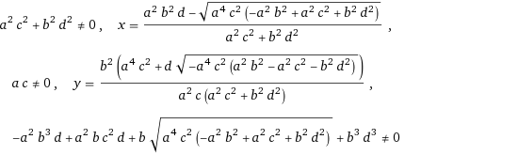
Open code

